**SUPPLEMENTAL HANDOUT ON EXCEL**

1. Using Excel as a calculator
2. Using Excel as a spreadsheet
   1. Cell referencing
   2. Copying and pasting (with “local referencing”)
   3. Copying and pasting (with “anchoring”)
   4. “Paste value”
3. Useful functions in Excel
   1. Miscellaneous functions for individual cells
   2. Functions for arrays: SUM, COUNT, PRODUCT, MAX, MIN, PERCENTILE, COUNTIF, MATCH, INDEX
   3. Boolean functions: IF, AND, OR
4. Keyboard shortcuts
   1. CTRL+ARROW
   2. SHIFT+ARROW
   3. CTRL+SHIFT+ARROW

**1. Using Excel as a calculator**

**Type “=” and then the formula you want calculated**

|  |  |  |
| --- | --- | --- |
| **Example** | **Interpretation** | **Output in Excel** |
| **=2+4** | Add 4 to 2 | 6 |
| **=2-4** | Subtract 4 from 2 | -2 |
| **=2*4** | Multiply 2 by 4 | 8 |
| **=2/4** | Divide 2 by 4 | 0.5 |
| **=2^4** | Compute 2 to the 4th power (i.e., 2*2*2*2) | 16 |
| **=2^(1/4)** | Compute 4th root of 2 (find x such that x4 = 2) | 1.18921 |
| **=ln(2)** | Take natural logarithm of 2 (i.e., find x such that ex = 2) | 0.69315 |
| **=exp(2)** | Exponential 2 (compute 2.718282) | 7.38906 |

**2. Using Excel as a spreadsheet (cell references in Excel)**

2a. Cell referencing

**Use “=[cell number]” to use the value from the indicated cell**

Example 2.1:

* In cell A1, type **2** and press Enter.
* In cell C1, type **=A1*3** and press Enter. This means to take the value in cell A1 when doing calculations.

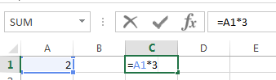

* The value in C1 should show **6**, since 2 [the value from cell A1] * 3 = 6
* Now change cell A1 to **4**. The value in cell C1 will now change to **12** (i.e., the value in cell A1 times 3)

2b. Copying and pasting (“local referencing”).

**If a cell has references to other parts of a spreadsheet, use “CTRL+C” to copy the references in that cell; use “CTRL+V” to paste references into a new cell, and the references will be changed relative to the location of the original cell**

Example 2.2:

* In cell A1, enter **1**; in cell A2, enter **2**; in cell B1, enter **3**; in cell B2, enter **4**.
* In cell D1, type **=A1**. This means to take the value in cell A1.

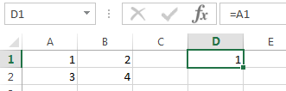

* Now copy (**Ctrl+C**) cell D1, then move to cell E1 and paste (**Ctrl+V**). The formula in cell D2 should say **=B1**. When a cell is copied one cell to the right, its cell references are updated one cell to the right (“local referencing”), in this case from “A1” 🡪 “B1”

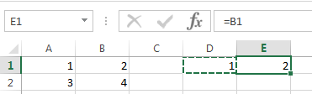

* Now copy (**Ctrl+C**) cell E1, then move to cell E2 and paste (**Ctrl+V**). The formula in cell D2 should say **=B2**. When a cell is copied one cell down, its cell references are updated to one cell down as well, here from “B1” 🡪 “B2”.

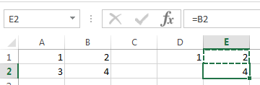

2c. Copying and pasting (“anchoring”).

**Put a $ sign in front of a cell reference’s letter to prevent updating [to “anchor”] the column when copying and pasting a cell, and put a $ sign in front of a cell reference’s number to prevent updating the row number when copying and pasting a cell.**

**Use F4 to cycle the cell through the following:**

* **anchor both row and column [the first time F4 is pressed]**
* **anchor only the row [so columns will be updated, but not rows]**
* **anchor only the column [so rows will be updated but not columns]**
* **no anchoring [back to local referencing]**

Example 2.3: fixed cell reference

* In cell A1, enter **1**; in cell A2, enter **2**; in cell B1, enter **3**; in cell B2, enter **4**.
* In cell D1, type **=A1**, then press **F4**. The formula in the cell should be **=$A$1**
* Now copy cell D1 to cell E1. Unlike in the previous example, where the value in cell E1 was 2, the value in cell E1 will be **1**. Because the references are “anchored”, then the reference will always be to A1, no matter the location of the destination cell.
* Now copy cell E1 to cell E2. The formula in cell E2 should still be **=$A$1**

Example 2.4: anchoring rows but not columns

* In cell D1, type **=A1**, then press **F4**, then press **F4** again. The formula in the cell should be =**A$1**. “A$1” means that, when the contents of the cells are copied, the column will be updated based on what column the cell is copied to, but the row will not.
* Copy cell D1 to cell E1. The formula in cell E1 should be **=B$1** [the column reference is updated; so copying one cell to the right resulted from “**A**$1” 🡪 “**B**$1”]
* Copy cell E1 to cell E2. The formula in cell E2 should still be **=B$1** [the row reference is not updated, because of the $ in front of the 1; so, no matter how many cells downward the cell is copied to, the reference will stay “B**$1**.”]

Example 2.5: anchoring columns but not rows

* In cell D1, type **=A1**, then press **F4**, then press **F4** again, then press **F4** a third time. The formula in the cell should be **=$A1** “$A1” means that the column will not be updated, but the row will be updated.
* Copy cell D1 to cell E1. The formula in cell E1 should be **=$A1** [the column reference is not updated, because of the $ in front of the A]
* Copy cell E1 to cell E2. The formula in cell E2 should still be **=$A2** [the row reference is updated]

Example 2.6: Multiplication table

* In cell B1, enter 1. In cell C1, enter “**=B1+1**”. Copy cell C1 into D1, etc., until column K. You will have a row with the numbers 1 through 10.
* In cell A2, enter 1. In cell A3, enter “**=A2+1**”. Copy cell A3 into A4, etc., until row 11. You will have a column with the numbers 1 through 10.
* In cell B2, enter “**=$A2*B$1**”. The cell references are such that, if this cell is copied, the multiplication will always be based on the value from Column A (using the appropriate row number), and the value from Row 1 (from the appropriate column).
* Copy cell B2 into the cells of the table (down to cell K11) to fill in the multiplication table. Note that if differing anchoring schemes had been used, the table would have been incorrect (it may be instructive to see the various incorrect multiplication tables that would arise if incorrect anchoring schemes are used).

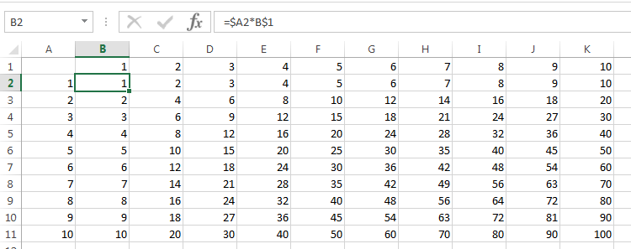

2d. “Paste value”

**Use copy (CTRL+C) and “paste special 🡪 Value” (ALT+E, S, V) to copy the numerical value of a cell rather than the cell’s references**

Example 2.7: Multiplication table

Move to cell K11. Then copy the cell (**CTRL+C**), move to cell M1, and then “paste special 🡪 value” (**ALT+E, S, V)**. The value of the original cell (“100”) is pasted into cell M1.

**3. Some useful functions in Excel**

3a. Miscellaneous examples for individual cells:

* **=YEAR( [date] )** returns the year for a given date
* **=RIGHT( [cell], n)** returns the last n characters in a cell
* **=ROUND( [number], 0)** rounds a number to the nearest integer
* **=FLOOR( [number], 1)** returns the integer part of a number, dropping the decimal part

3b. Functions for arrays of values: if a range of numbers is highlighted in Excel …

* “**=SUM**([*array*])” adds all the numbers
* “**=COUNT**( [*array*])” counts the number of numerical values
* “**=PRODUCT**( [*array*] )” multiplies all the numbers
* “**=MAX**( [*array*] )” gives the largest number in the list
* “**=MIN**( [*array*])” gives the smallest number in the list
* “**=PERCENTILE(** [*array*], **p**)” gives the (interpolated) value **x** in the [*array*] such that (**p** x 100%) of the values in the [*array*] are less than or equal to **x**
* “**=COUNTIF**( [*array*], **x**)” counts how many items in the [array] are exactly equal to **x**. For example, using “=COUNTIF(A1:A20,3)” counts how many items between A1 and A20 are exactly equal to 3.
* “**=COUNTIF**( [*array*], “condition”)” counts how many items in the [range] meet the given “condition”. For example, using “=COUNTIF(A1:A20, “>=2”)” counts how many items between A1 and A20 are greater than or equal to 2
* “**=MATCH**( **x**, [*array*], 0)” tells the first item number in the [array] that is equal to **x**. For example, given an array of “2, 4, 6, 8, 10, 6”, using “=MATCH(6, [array], 0)” would give 3: the third item in the list is equal to 6
* “**=INDEX( n**, [*array*])” gives the nth item in an array. For example, given an array of “A, B, C, D, E”, using “=INDEX( [array], 4)” would give the value of “D”: the fourth item in the list was “D”
* Note: given a list of employees and their salaries, the INDEX and MATCH can be nested to find the name of the person with the highest salary, using

**=INDEX(MATCH( max( [*salary array*] ), [*salary array*], 0), [*employee name array*] )**

3c. Boolean functions

* “**=IF**(*condition*,value1,value2)” returns *value1* if the stated *condition* is TRUE, and returns *value2* otherwise … “=IF(A1>2,1,-1)” will return a value of 1 if cell A1 is larger than 2, and will return a value of -1 if cell A1 is not larger than 2.
* “**=AND**(condition1,condition2[,…])” returns a value of TRUE if all conditions are true, and returns a value of FALSE if any condition is false. To convert this to a numerical zero-one variable, use “=1*AND(condition1,condition2)” … this will give a value of 1 if both conditions are true, 0 otherwise.]
* “**=OR**(condition1,condition2[,…])” returns a value of TRUE if any condition is true, and returns a value of FALSE if all conditions are false. To convert this to a numerical zero-one variable, use “=1*OR(condition1,condition2)” … this will give a value of 1 if either condition is true, 0 otherwise
* “**=1\***(statement)” will be 1 if the statement being evaluated is true, 0 otherwise. For example, “=1*(2 > 1)” will return a value of 1, since 2 is larger than 1; “=1*(1 > 2)” will return a value of 0. This is a simpler way to express the expression “=IF(*condition*, 1, 0)”, which also returns a 1 if the *condition* is true and 0 otherwise.

1. **Keyboard shortcuts**

**4a. Use CTRL+ARROW to “jump” the cursor in the indicated arrow direction:**

* + - If the current cell is BLANK, then the cursor will move in the indicated direction until it reaches the first non-blank cell (or to the edge of the spreadsheet)
    - If the current cell HAS contents, then the cursor will move in the indicated direction until it reaches the end of filled cells in that direction.

Example 4.1: moving rapidly through a column of numbers

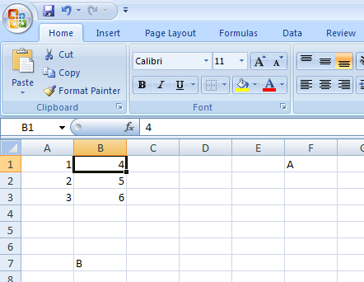

* Starting from cell B1, pressing CTRL+“right arrow” will jump the cursor to cell F1; from F1, pressing CTRL+“left arrow” will jump the cursor back to cell B1.
* From cell B1, pressing CTRL+“down arrow” will jump the cursor to the end of filled cells, to cell B3. Pressing CTRL+ “down arrow” again will jump the cursor to cell B7.

**4b. Use SHIFT+ARROW to highlight multiple cells at once (useful when pasting).**

Example 4.2: filling in formulas

* In cell A1 through A10, enter **1**, **2**, **3**, …, **10**.
* In cell C1, type **=A1*2**
* Press **CTRL+C** to copy cell C1.
* While holding down **SHIFT**, press the down arrow 10 times. A total of 10 cells should be highlighted in gray.
* Press **CTRL+V** to paste the contents of the cells. Ten cells should be filled in, all at once.

**4c. Use CTRL+SHIFT+ARROW to highlight blocks of cells with minimal keystrokes**

Example 4.3: Generating long lists of sequential numbers

* In cell A1, enter **1**. This will be the starting number.
* In cell A2, type **=A1+1**, if you want to increment by one each time.
* Highlight cell A2, then copy (**CTRL+C**).
* While holding down shift, press **PageDn** a few times. Now press paste (**CTRL+V**) to fill in the column.
* Move up to the bottom of the column by highlighting a cell in column A, then pressing **CTRL+(down arrow)**.
* Move to the top of the spreadsheet by pressing and press **CTRL+(up arrow)**.
* In cell C1, type **=sum(**, then highlight cell A1, then press **CTRL+SHIFT+(down arrow)**, then type **)** and press **Enter**. This gives the sum of the numbers you have created. Now do the same thing using the mouse: in cell D1, type **=sum(**, then highlight the numbers in column A using the mouse, then type **)** and press **Enter**.
  + Which technique was faster to get the sum?

Example 4.4 Highlighting large blocks of data

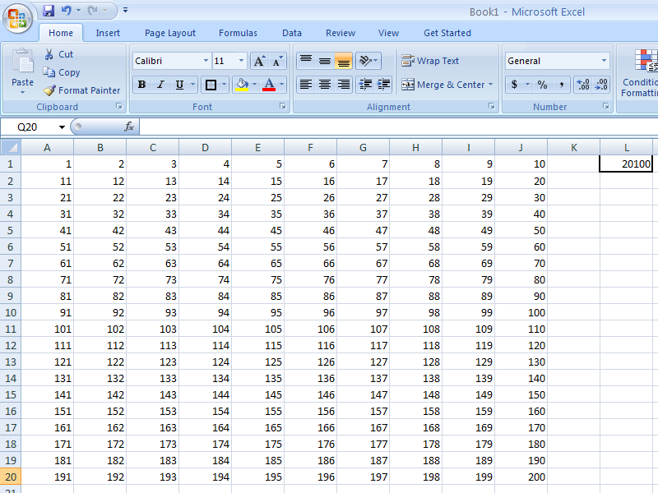

The sum of the 200 numbers above can be obtained quickly as follows:

* go to cell L1
* type “=SUM(” … leave the parentheses open for the moment
* press CTRL+“left” (gets to E1)
* press CTRL+SHIFT+“left” (now highlights all cells in row 1)
* press CTRL+SHIFT+“down” (now highlights the entire block)
* type “)”, press Enter